Experiment No.10
Name :-Shivani Kolekar
Roll No:-24141031
Batch:-I2
Title:-8-Queens Problem using Back Tracking.
Programm:-
#include <stdio.h>
#define N 8
char board[N][N];
// Check if it's safe to place a queen at board[row][col]
int isSafe(int row, int col) {
int i, j;
// Column check
for (i = 0; i < row; i++)
if (board[i][col] == 'Q') return 0;
// Upper-left diagonal check
for (i = row, j = col; i >= 0 && j >= 0; i--, j--)
if (board[i][j] == 'Q') return 0;
// Upper-right diagonal check
for (i = row, j = col; i >= 0 && j < N; i--, j++)
if (board[i][j] == 'Q') return 0;
return 1;
}
// Recursive function to solve the problem
int solve(int row) {
if (row >= N) return 1; // All queens placed

for (int col = 0; col < N; col++) {
if (isSafe(row, col)) {
board[row][col] = 'Q';
if (solve(row + 1)) return 1;
board[row][col] = '.';
}
}
return 0;
}
// Function to print the board as a real table
void printBoard() {
printf("\n 1 2 3 4 5 6 7 8\n");
printf(" +------------------------+\n");
for (int i = 0; i < N; i++) {
printf("%d |", i + 1);
for (int j = 0; j < N; j++) {
printf(" %c", board[i][j]);
printf(" ");
}
printf("|\n");
}
printf(" +------------------------+\n");
}
int main() {
// Initialize board
for (int i = 0; i < N; i++)
for (int j = 0; j < N; j++)
board[i][j] = '.';
if (solve(0)) {
printf("Solution for 8-Queens Problem:\n");
printBoard();
} else {
printf("No solution exists.\n");
}
return 0;
}
Output:- 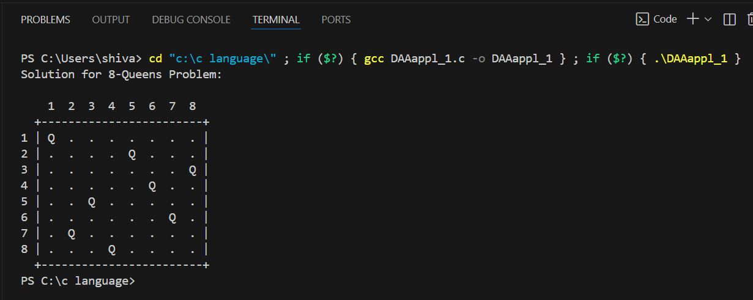

Complexity
- Time Complexity: O(N!)
- Space Complexity: O(N²)
Applications
- Constraint Satisfaction Problems (CSP)
  - 8-Queens is a classic example of CSP in AI, where variables must satisfy constraints.
- Artificial Intelligence & Game Development
  - Used to teach backtracking algorithms and state-space search techniques.
- Puzzle Solving & Educational Tools
  - Helps students understand recursion, backtracking, and problem-solving strategies.
- Optimization Problems
  - Concepts from N-Queens are applied in scheduling, resource allocation, and task assignment.
- Genetic Algorithms & Heuristics
  - Used as a benchmark problem to test optimization heuristics.
- Chessboard-related Problems
  - Helps in designing algorithms for chess puzzles and piece placement scenarios.

Conclusion:-The 8-Queens problem demonstrates the power of backtracking to efficiently explore solutions for constraint-based problems.

